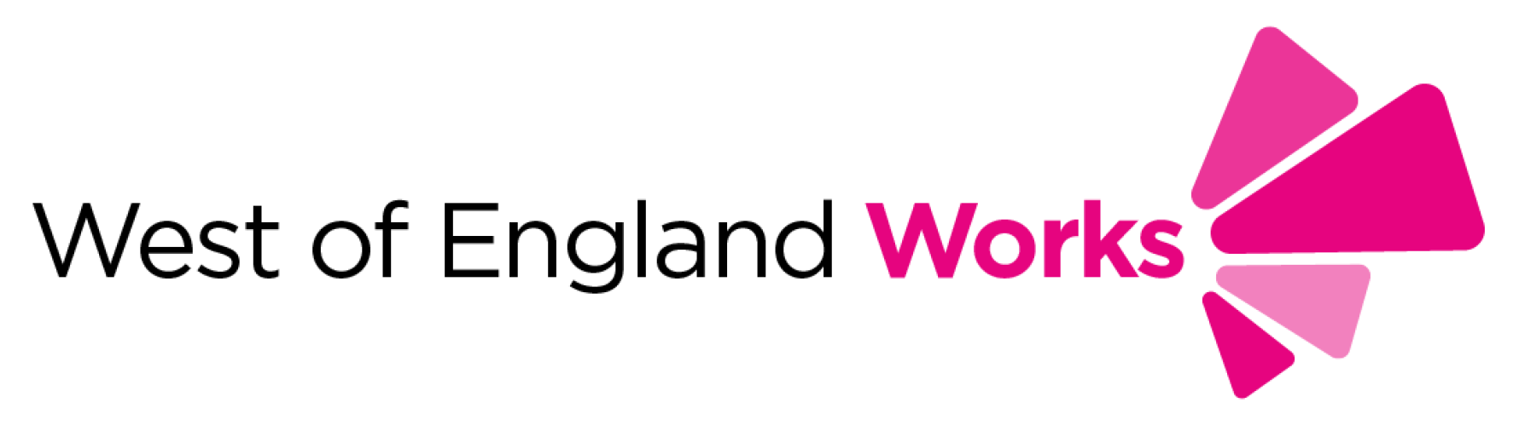
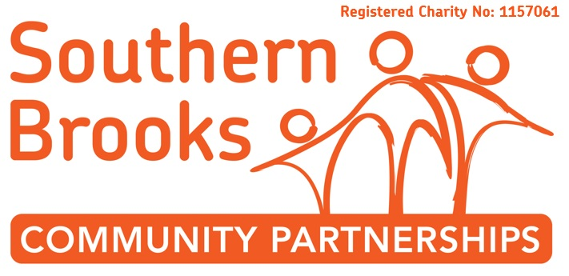

Register of Interest
Date |  | Date Received  (office use only) |  | Reference  (office use only)
Participant Information
Name |  | Date of Birth |  | Age
Address |  |  |  | Gender
Email Address |  | Mobile Number |  | National Insurance
Emergency  Contact Person |  | Emergency Contact Details
Do you want to progress into: | Please tick one or more boxes:  □ Employment  □ Education  □ Training  □ Volunteering | Is English your first language? |  |  | □ Yes □ No
 |  | Do you have any difficulties with reading or writing? |  |  | □ Yes □ No
 |  | Are you an Asylum Seeker or Refugee? |  |  | □ Yes □ No
 |  | Do you have any special requirements i.e. accessibility?  If so, please state: |  |  | □ Yes □ No
Please return this form to:
BBO, Southern Brooks Community Partnerships, Coniston Community Centre, Coniston Road, Patchway, BS34 5JP

