ROLE DESCRIPTION

POST TITLE: | Holiday Activities Assistant Volunteer
RESPONSIBLE TO: | Community Volunteer Co-ordinator – Catherine Coleman
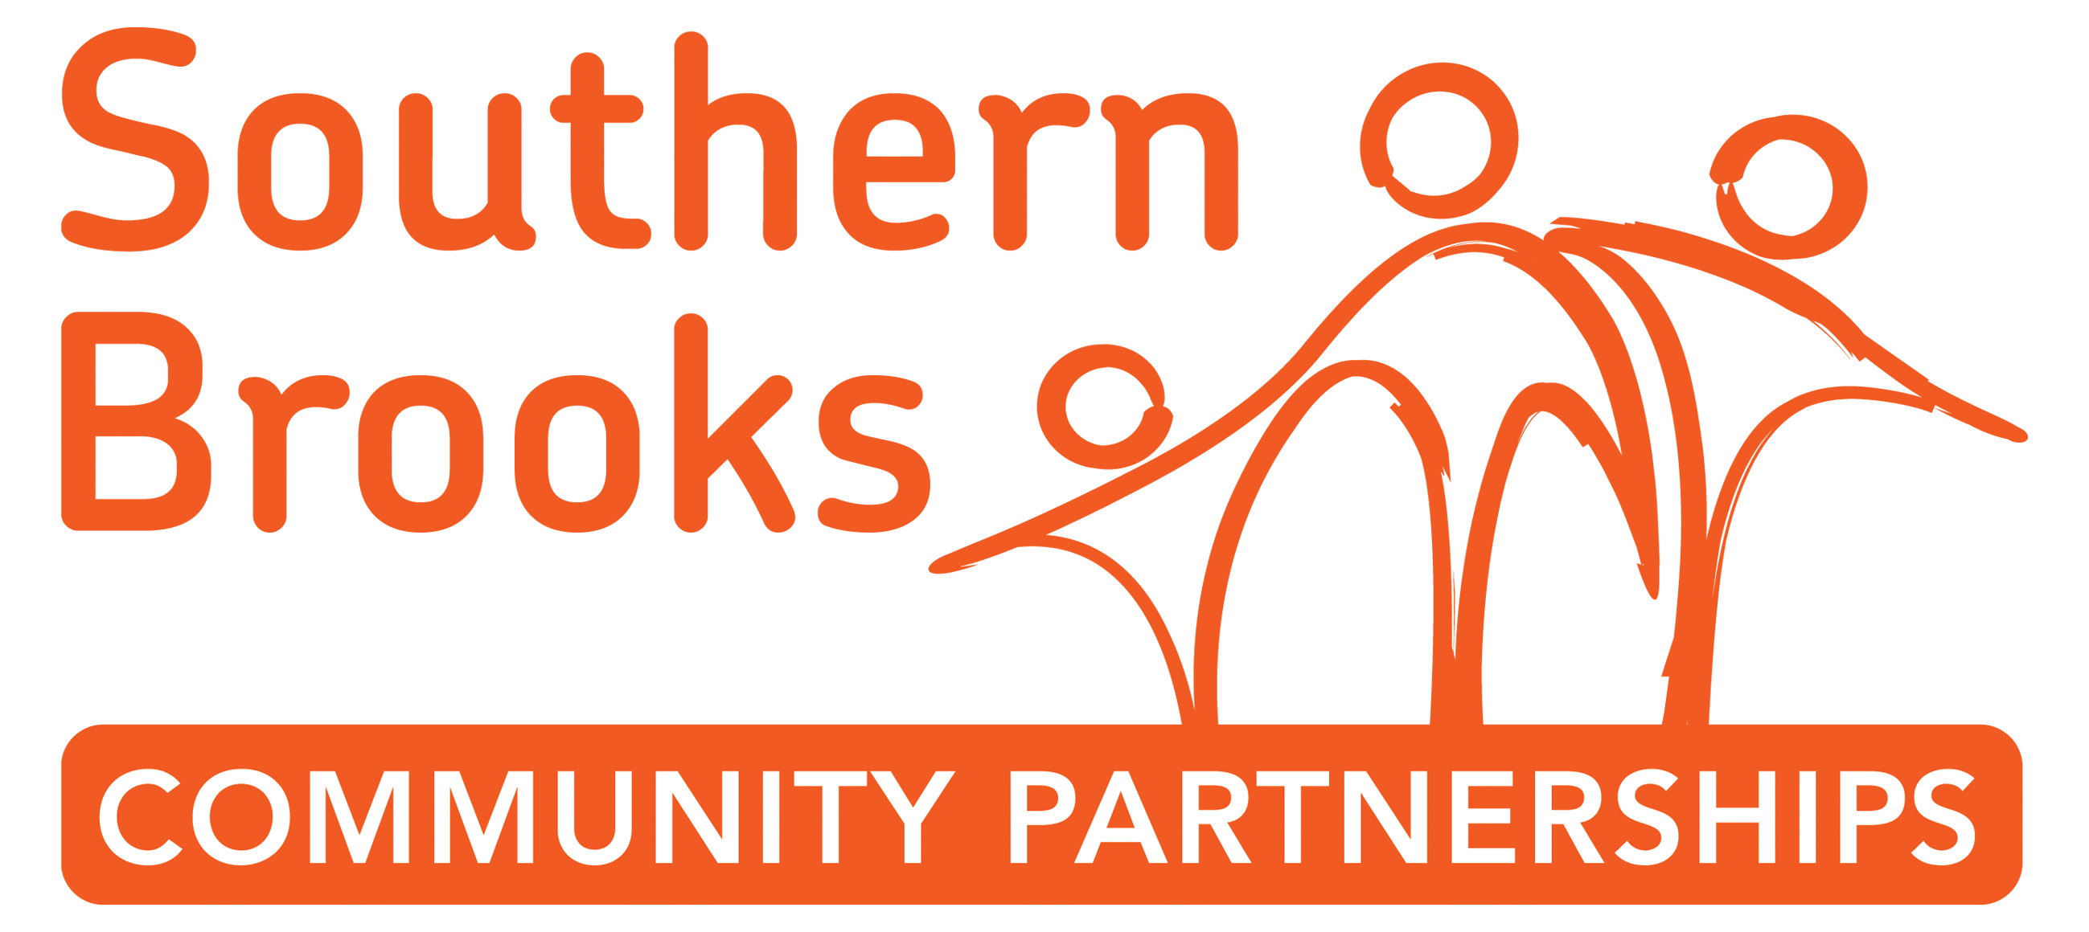
A bit about the project |   During the school holidays we want to offer fun, family friendly activities for our local family customers in the Brooks community cafes.    Family activities include: biscuit decorating, drawing competitions, simple crafts, storytelling, fancy dress.  We want the Brooks cafes to be a welcoming, happy and friendly place for families to do some free activities together.  There are 2 community cafes – one in Conistons Community Centre in Patchway and the other in The Park Centre, Kingswood. Both are looking for volunteers to help run family activities.
Your Tasks | - Help set up activities in the café e.g. lay out craft and biscuit decorating.  - Welcome families to the café and encourage them to have a go.  - Chat to families and children, demonstrate the activity and encourage them to be creative and have fun.    - Help tidy up at the end of the session and put everything away.  - Read a story book to the children and families.  - Help promote the activity through giving out flyers and inviting people in.  - If you’re keen(!) dressing up as a Halloween character.  This role would suit you if you can meet the criteria below.  About you…  You might be aiming to find employment working with families or children or have some time during school holidays to support a local charity.  Skills  - Ability to work as part of a team, with excellent people skills  - Confident to speak with families and children  - Great attitude to customer service and understand the importance of building good relationships with customers  - Able to make simple crafts  Personal Qualities  - Friendly and welcoming to everybody who works and uses the café  - Want to take social action and make a difference to a community  - Eager to learn  - Enjoy working in a busy environment  - Happy to muck in and get your hands dirty  - Happy to support Southern Brooks and promote community development work we do
Time |   This is a short-term commitment for 5 days during schools holidays.  October Half term Monday to Friday – 9am – 12pm. (you don’t have to do everyday)  There are 2 positions available – you’re welcome to apply with a friend.
Support and Training | All volunteers will be fully supported through supervision, training and peer support.  A member of staff will lead the activities and support you.  We work with volunteers to identify skills they want to develop while they are volunteering for example, building up the confidence to read a story to a group.
Special notes | Your travel expenses are reimbursed for every volunteering session.
Apply | Closing date Friday 20th October 2017 – ready for the October Half term holidays.  Complete the form online at www.southernbrooks.org.uk or email volunteering@southernbrooks.org.uk Or return a paper copy to the Brooks café  Call 01454 868 570 and ask for Catherine Coleman for assistance with applying



