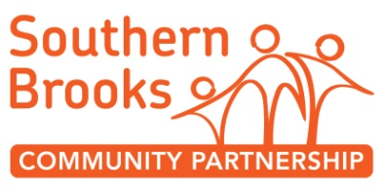
Positive State of Mind Group ROLE DESCRIPTION

POST TITLE: | Volunteer Peer Support Group Assistant
RESPONSIBLE TO: | Rosie Sinfield - Positive State of Mind

Main Purpose | Overview  Positive State of mind group is a group for people with lived experience of poor mental health. We meet on a weekly basis and provide support to one another through structured conversations, cups of tea and games.  Tuesday 4:30pm – 6:00 pm Positive State of Mind – Made forever, Kingsmeadow  Wednesday 7:15pm – 9:15pm Positive Sate of Mind – Kingswood Library  Tasks  - Be the additional person to support staff member opening up and closing down the buildings. This is a crucial safeguarding requirement for you to be present when this happens.  - Support staff to maintain a good dynamic within the group.  - Facilitate the group occasionally in the event of staff needing to deal with confidential issues  - General group facilitation and set up tasks e.g . welcoming group members, offering tea, washing up mugs, being warm and inviting
Time | There are two groups which meet on alternate weeks. You’re welcome to support one or both groups.  Tuesday 4:30pm – 6:00 pm Positive State of Mind – Made Forever Youth Centre, Kingswood  Wednesday 7:15pm – 9:15pm Positive Sate of Mind – Kingswood Library
Location | Made Forever Youth Centre, Kingswood or Kingswood Library
Support and Training | Volunteer Induction session to the organisation lasting 2 hours  Supervision and support from your staff supervisor.  You will receive training in data protection, confidentiality and safeguarding.
Special notes | A DBS check is needed for this role. South Brooks Community Partnerships pay for this.  We pay for travel expenses.
About you  You can… | - Confidently welcome people in a friendly and non judgemental manner  - Follow safeguarding procedures  - Travel to the locations and arrive promptly
You are…. | - Interested in mental health, wellbeing, peer support  - Willing to learn about safeguarding  - Friendly and empathetic

