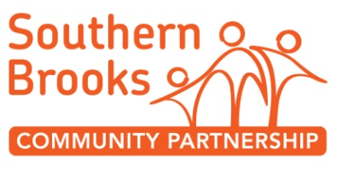
Positive State of Mind Group ROLE DESCRIPTION

POST TITLE: | Volunteer Group Assistant
RESPONSIBLE TO: | Sato Black

Main Purpose | Overview  The Yate Wellbeing Drop-In is an informal and relaxed opportunity, for people to find ways to improve their wellbeing. WE meet on a weekly basis and provide support to one another through sociable activities, (eg art, craft, games, trips, guest speakers) over a cup of tea.  Tasks  - Be the additional person to support staff member opening up and closing down the buildings. This is a crucial safeguarding requirement for you to be present when this happens.  - Support staff to maintain a good dynamic within the group.  - Facilitate the group occasionally in the event of staff needing to deal with confidential issues  - General group facilitation and set up tasks e.g . welcoming group members, offering tea, washing up mugs, being warm and inviting
Time | Tuesdays 12.30-13.30
Location | Tyndale Avenue, Yate
Support and Training | Volunteer Induction session to the organisation lasting 2 hours  Supervision and support from your staff supervisor.  You will receive training in data protection, confidentiality and safeguarding.
Special notes | A DBS check is needed for this role. South Brooks Community Partnerships pay for this.  We pay for travel expenses.
About you  You can… | - Confidently welcome people in a friendly and non judgemental manner  - Follow safeguarding procedures  - Travel to the locations and arrive promptly
You are…. | - Interested in mental health, wellbeing, peer support  - Willing to learn about safeguarding  - Friendly and empathetic

