Volunteer Gardener Role Description
POST TITLE: | Volunteer Gardener
RESPONSIBLE TO: | Catherine Coleman – Community Volunteer Coordinator

Main Purpose | Overview  The old outdoor space at Made Forever Community Centre was plain grass and paving slabs. We have spent this year, turning it into a community garden space for everyone who visits Made Forever Community Centre to use and enjoy. A weekly Gardening Club is now running every Wednesday, as well as Community Learning Courses on how to grow your own veg. Fruit, vegetables, flowers and trees are all flourishing in the space.  We are now looking for volunteers to join our team of happy gardeners, to support the ongoing maintenance of the space. You can choose to do this as part of the weekly gardening club on a Wednesday afternoon, or at other times outside of this.  Tasks  - Participate in general garden maintenance e.g. planting, taking cuttings, deadheading, pruning and weeding.  - Share ideas about how to use and organise the garden with gardening club members and other users of the community garden.  - Help develop a vision and plan for the community garden.  - Support fundraising activities to purchase equipment and plants for the garden.  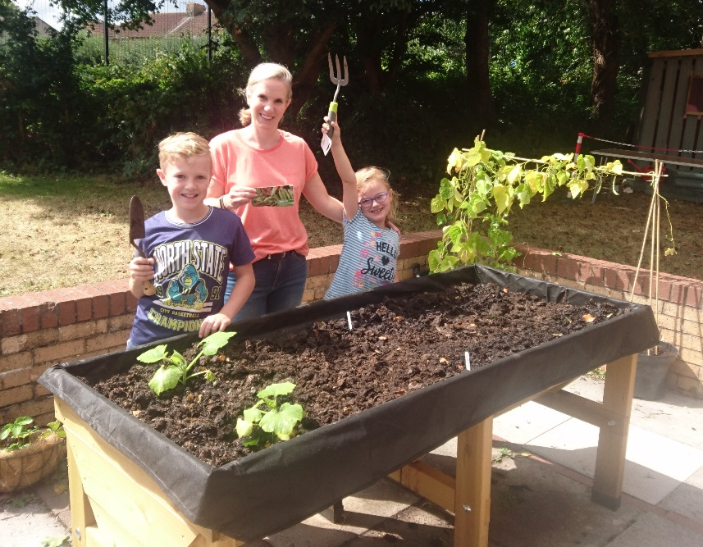  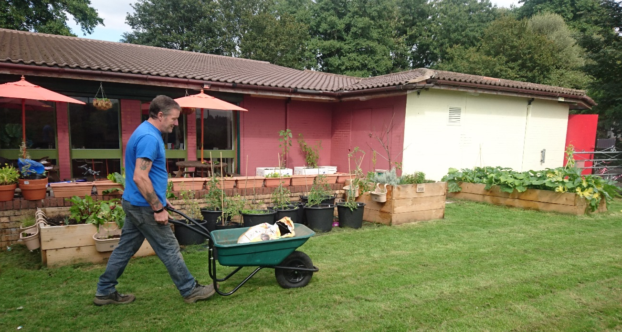  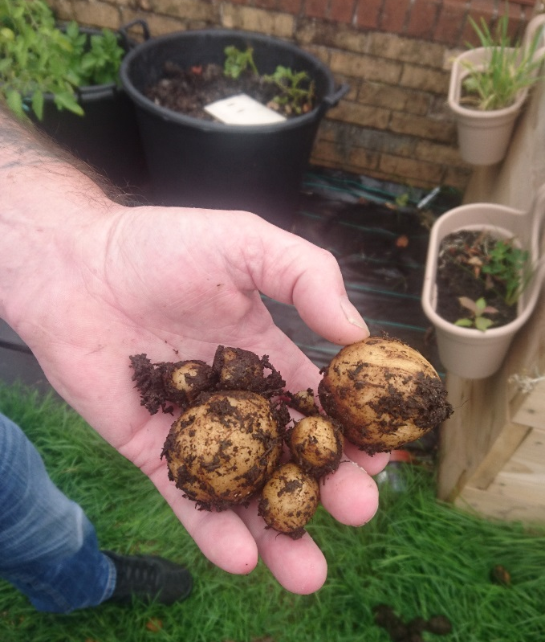  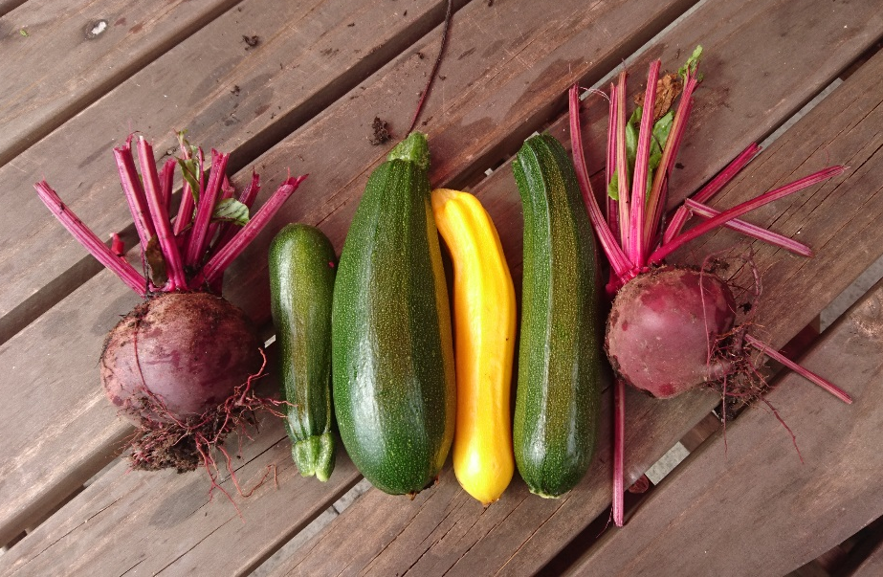
Time | Flexible.  Gardening club meets weekly on a Weds from 1.30pm – 2.30pm
Location | Made Forever Community Centre, Fisher Road, Kingswood.
Support and Training | Volunteer Induction session to the organisation lasting 2 hours  Supervision and support from your staff supervisor.  You will receive training in safeguarding.
Special notes | We pay for travel expenses.
About you  You can… | - Physically able to do gardening tasks  - Understand basic principles of gardening and growing plants
You are…. | - Interested in gardening and making outdoor spaces lovely places to be  - Passionate about being outdoors  - Happy to see children and families enjoying gardens

