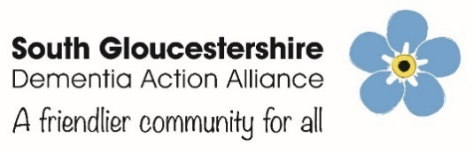

Membership Form

Our Mission: Helping communities and organisations support people to live well with dementia, by working towards the outcomes of the National Dementia Declaration *
Our Values

- Equality and Anti-discrimination
- Social Justice
- Collective Action
* The National Dementia Declaration
- We have the right to be recognised as who we are, to make choices about our lives including taking risks, and to contribute to society. Our diagnosis should not define us, nor should we be ashamed of it.
- We have the right to continue with day-to-day and family life without discrimination or unfair cost, to be accepted and included in our communities and not live in isolation or loneliness.
- We have the right to an early and accurate diagnosis, and to receive evidence based, appropriate, compassionate and properly funded care and treatment, from trained people who understand us and how dementia affects us. This must meet our needs, wherever we live.
- We have the right to be respected, and recognised as partners in care, provided with education, support, services, and training which enables us to plan and make decisions about the future.
- We have the right to know about and decide if we want to be involved in research that looks at cause, cure and care for dementia and be supported to take part.
Our vision for a dementia friendly South Gloucestershire

People with dementia, and the people who care for them:
- Are able to live full involved and creative lives
- Are valued as part of their families, friendships and social networks
- Continue to do the things that have been important to them in their lives
- Are able to start and / or join new things
- Can receive unobtrusive support as the dementia progresses and needs change to carry on with their lives
- Are recognised and valued for who they are (their roles, responsibilities, and identities) rather than merely seen in terms of the symptoms of their dementia, their role as a carer and their assumed need for services
- Live in neighbourhoods that are welcoming, accepting, supportive and accessible to everyone
- Use everyday facilities without stigma and embarrassment
- Have an understanding of the benefits of early diagnosis, and the support services that are available.
- Community Empowerment
- Working and Learning Together

For further information contact: Winsome Barrett-Muir, Community Development Project Coordinator for SGDAA on 01454 868570 / 07969 189333 or email: dementia@southernbrooks.org.uk
www.southernbrooks.org.uk www.facebook.com/SouthGlosDAA @SouthGlosDAA
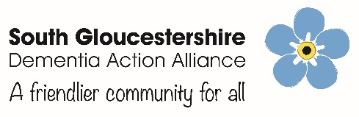
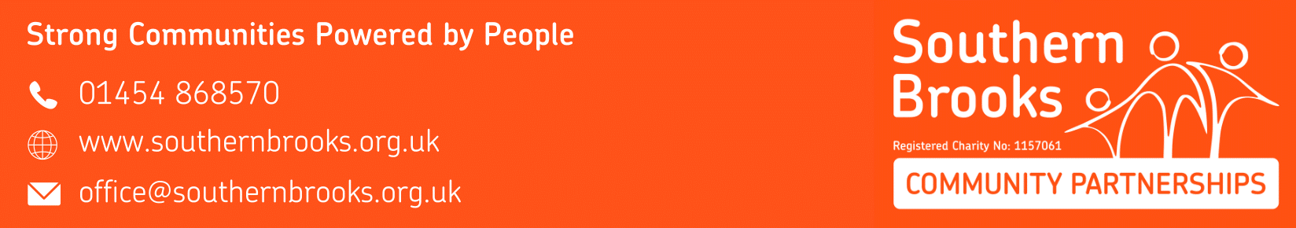
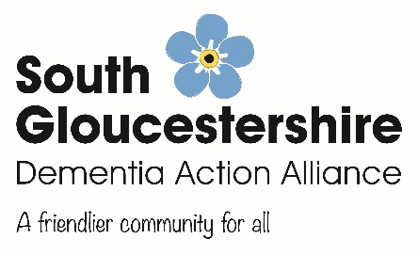
Your Details:
Name: …………………………………………………………………………………………………………………………………………………………..
Address: ……………………………………………………………………………………………………………………………………………………….
Email: ………………………………………………………………………………… Telephone: ……………………………………………………..
Organisation: ………………………………………………………………………….. Role: ………………………………………………………….
This information will be kept on file so that we can communicate with you regarding the above.
We would like to send you occasional updates on our work including our regular Yes/No SGDAA newsletter and information about events which may interest you
Mailing / Contact preferences can be changed at any time by contacting: dementia@southernbrooks.org.uk
Raise awareness of dementia
- Book a Dementia Friends information session
- Agree to our Vision and Mission Statement
- Volunteer to help at one of our Memory Cafes, or help a family member or friend living with dementia
Become a member of the South Gloucestershire Dementia Action Alliance (SGDAA)
- Join as a member, and agree a minimum of three Dementia Friendly actions for your organisation
Become a Dementia Ambassador volunteer and:
- Train as a Dementia Friends Champion and run Dementia Friends sessions for SGDAA
- Run a stall at a community event, shopping centre etc
- Offer office administrative support to the SGDAA
- Share your experience of living with dementia, and help remove stigma and misunderstanding
- Share your experience of caring for someone with dementia
- Other:
________________________________________________________________

South Gloucestershire Dementia Action Alliance
What can you do to help raise awareness of Dementia in South Gloucestershire?

