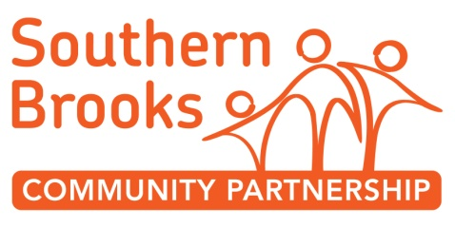

ROLE DESCRIPTION
POST TITLE: | Volunteer Assistant Youth Worker
RESPONSIBLE TO: | Youth Work Manager

Main Purpose | The Youth Work Team provides a range of activities and support for young people in Patchway and surrounding areas. The team are looking to work alongside a network of energetic volunteers to support the Junior Youth Sessions .  We run many projects and different activities during the regular weekly sessions. This may include arts activities, music, sports, gardening and cooking.  Role of Volunteer Assistant Youth Worker  - To assist the Youth Work Team in their day-to-day work  - Attend relevant training and supervision
Support and Training | All volunteers will be fully supported through supervision, training and peer support.  We are able to work with volunteers to identify skills they want to develop while they are volunteering.
Time | Various, but usually between 3.30-9pm  A regular commitment is expected for weekly sessions.
Special notes and conditions | SBCP is committed to safeguarding and promoting the safety and welfare of children, young people and vulnerable adults.  All youth work volunteers will be subject to a Disclosure and Barring Service Check (DBS) and are exempt from the Rehabilitation of Offenders Act. All offences will be considered.  In return for your commitment and dedication to SBCP we offer regular training opportunities, active supervision and individual development, together with working in a fully supportive team.
Your Skills | - Ability to work and communicate with young people from a range of diverse backgrounds and cultures  - Ability to work as part of a dynamic team  - A working knowledge of safeguarding and child protection
Your Qualities | - Well organised  - Empathic and non-judgemental  - Committed to the ethos and values of youth work and community development  - Committed to Equal Opportunities and the development of the team  - Aware of own development needs and a commitment to addressing them
Desirable | - Knowledge of, or background in, working with young people or youth work  - Understanding of confidentiality, data protection and information sharing

